**A Penguin's Adventure (APA)**

*Level Designer: Ray Shao*

# **Story Background**

The main character of the story is a **Penguin**. The adventure starts at the **South Pole** (Tutorial). The poor penguin lost his living environment because of the **Greenhouse Effect**, but he decides to go on an **Adventure** to find a new living place on his own ……

# **Level Design (5)**

## **Tutorial (South-Pole)**

### **Mechanics**

New Mechanics: Normal pushable box; Trigger door; Unmovable Enemy; Bomb

### **Reference Diagram**

### **Level Story**

The Little Penguin woke up from a scene of frozen earth near the beach, and he decided to find a new place to live. The first area on the left of the diagram is the frozen earth area; it lets the players learn how to use WASD to control the character.

Going further, our little penguin came to the human living area and opened the door on his way.

Inside the door, the little penguin found a ship which could take him to another island. However, a seagull was on his way. The little penguin used the bomb to drive the seagull away and reached the goal.

## **Australia (RainForest)**

### **Mechanics**

Old Mechanics: Trigger Door; Bomb

New Mechanics: Movable Enemy; Water Pool

### **Reference Diagram**

### **Achievements**

Kill All the Enemies

Collect All Tools

Use No Tool

## 

## **Hawaii (Sea-Island)**

### **Mechanics**

Old Mechanics: Trigger Door; Bomb; Movable Enemy; Water Pool

New Mechanics: Elevator; Healing Item

### **Reference Diagram**

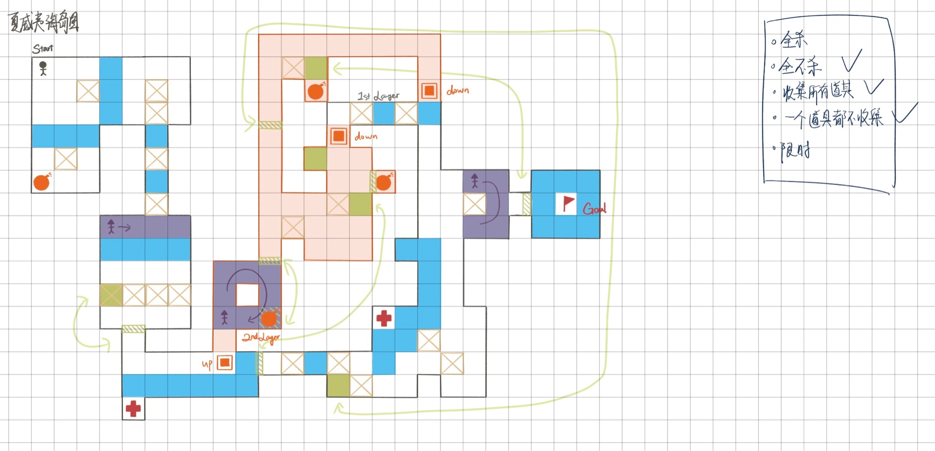

### **Achievements**

Kill No Enemy

Collect All Tools

Collect No Tool

## 

## 

## **Beijing (Hotel)**

### **Mechanics**

Old Mechanics: Trigger Door; Bomb; Movable Enemy; Elevator; Healing Item

New Mechanics: Invisible Enemy

Considering: Time Limit

### **Reference Diagram**

### **Achievements**

Kill No Enemy

Use No Tool

Full Heart Completion

## **Russia (Ice-Surface)**

### **Mechanics**

Old Mechanics: Trigger Door; Bomb; Movable Enemy; Water Pool; Elevator; Healing Item; Invisible Enemy

New Mechanics: Ice Surface; Limit Step Box

Considering: Fighting with Boss

### **Reference Diagram**

### **Achievements**

Kill No Enemy

Collect All Tools

Full Heart Completion

### **Level Story**

The Little Penguin reached the North Pole and said hi to the polar bear finally. They both got confused. The story ended. (?)